Alternative B Roll Creation (Free Tools)
Tools:
Video Generation - Google Flow
Asset Generation - Nano Banana or ChatGPT

🎬 B-Roll Scene 1: The AI "Signal in the Noise"
Script Placement: Play during the "Internal group chats / simple question" section.
- Start Frame (The Chaos) - Nano Banana:
Tool : https://aistudio.google.com/ or https://gemini.google.com/
Prompt: A futuristic digital interface in a vertical 9:16 portrait orientation, completely cluttered with thousands of overlapping, translucent message bubbles, conflicting chat lines, and notification icons in a chaotic disarray. The composition is filled from top to bottom with a messy mix of neon blues and purples. 8k, mobile-optimized composition.
- End Frame (The Clarity) - Nano Banana:
Tool : https://aistudio.google.com/ or https://gemini.google.com/
Prompt: A clean, dark, and organized vertical 9:16 digital interface. In the exact vertical center, a single, glowing golden profile icon pulses with a soft light. A subtle, stylized AI processor graphic hovers just above it. Minimalist aesthetic, centered for mobile screens.
- Video Transition Prompt (The Action) - Veo:
Tool : https://labs.google/fx
Prompt: A cinematic 9:16 vertical data-visualization effect. The chaotic sea of message bubbles is rapidly sucked into a central digital vortex in the middle of the portrait frame. They dissolve into light particles, revealing only the single, glowing golden profile icon in a clean, vertical space.
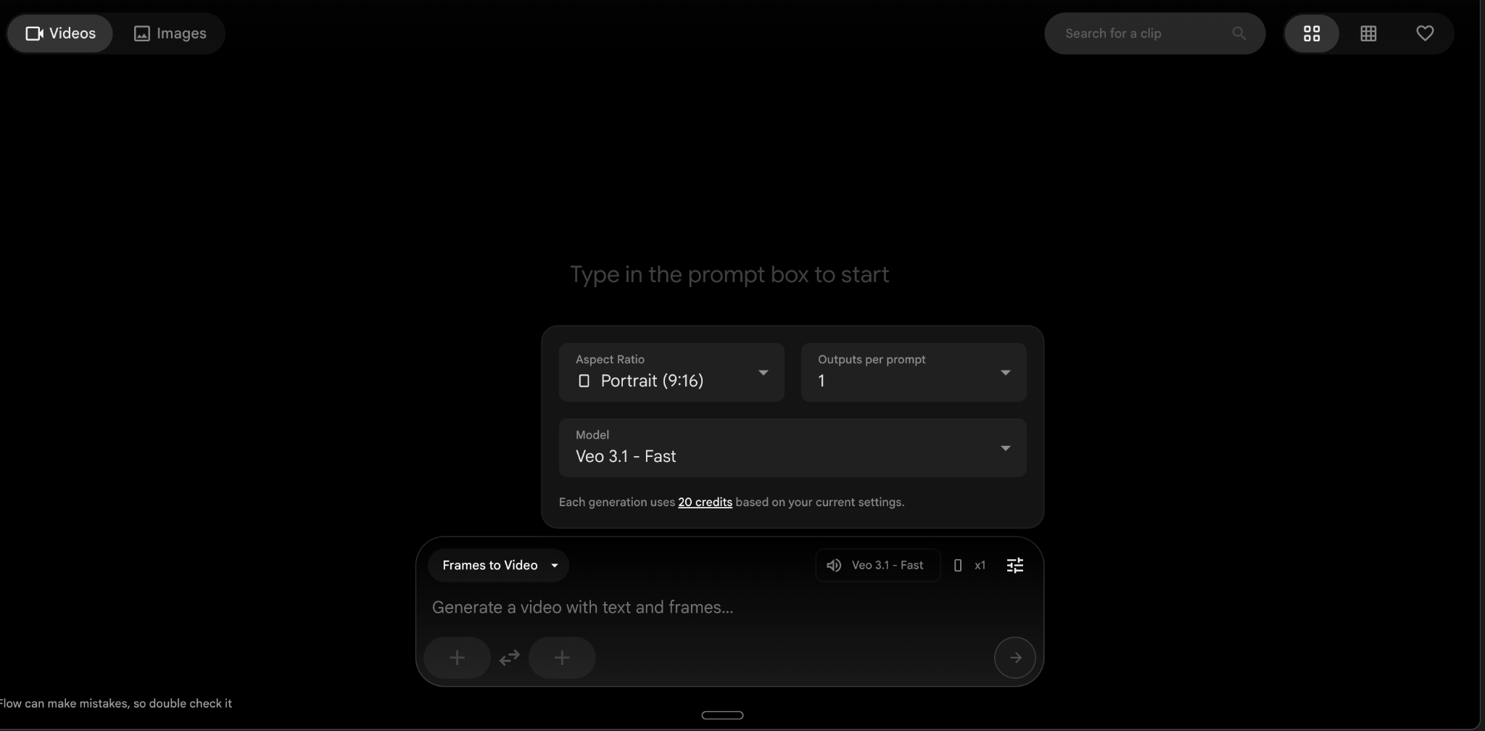

🎬 B-Roll Scene 2: "Visibility vs. Velocity"
Script Placement: Play during the "No office politics... just pure output" section.
- Start Frame (The Politics) - Nano Banana:
Tool : https://aistudio.google.com/ or https://gemini.google.com/
Prompt: A blurred, impressionistic vertical 9:16 photograph of a busy corporate boardroom viewed through frosted glass. The portrait orientation emphasizes the height of the room. Several indistinct figures in suits are gesturing. Harsh, warm orange lighting, conveying noisy, aggressive energy.
- End Frame (The Output) - Nano Banana:
Tool : https://aistudio.google.com/ or https://gemini.google.com/
Prompt: A sharp, high-resolution vertical 9:16 close-up of a pair of hands rhythmically typing on a sleek, backlit mechanical keyboard. The camera is angled to show the hands and the glowing keys at the bottom of the frame, with lines of green code scrolling on a monitor at the top. Calm, cool cyan tones.
- Video Transition Prompt (The Action) - Veo:
Tool : https://labs.google/fx
Prompt: A smooth 9:16 vertical rack focus and cross-dissolve. The blurry, noisy orange-toned boardroom scene at the top of the frame fades out as the sharp, cool-toned shot of the hands typing at the bottom comes into crystal-clear focus. A professional vertical transition representing clarity over noise.

Part 4.2 - Generate Music and Sound Effects
Tools:
Suno AI
ElevenLabs
Optional for this workbook.

Part 5 - Editing
Tools:
https://www.veed.io
or
DaVinci Resolve
Process:
- Upload A Roll
- Upload B Roll
- Add music
- Add text overlays
- Export as MP4
Tutorials:
VEED - https://www.youtube.com/watch?v=RRm_ruS_J_w
DaVinci - https://www.youtube.com/watch?v=LcGsaIV8QBY

Script Sample
Google's co-founder just promoted someone he didn't even know existed.

The crazy part? He let AI make the decision.

So, here's the thing.

Sergey Brin — yeah, the guy who built Google — went on the All In podcast and dropped a bomb.

He's been using AI to read through internal group chats.

Not to spy. To find out who's actually doing the work.

One day, he asked the AI a simple question:

"Who deserves a promotion in this chat?"

The AI didn't flag the loudest voice in the room.

Nope.

It picked a quiet engineer. A woman who barely spoke in meetings.

Brin admitted it himself: "I didn't even know she existed."

But here's where it gets interesting.

He took it to her manager.

The manager's response? "Yeah, you're right. She's been crushing it."

She got the promotion.

Think about it.

No office politics. No brown-nosing. No "visibility hacks."

Just pure output.

Brin's takeaway hit hard. Quote:

"Management is actually one of the easiest things for AI to handle."

Here's the bigger picture.

The era of "being seen" to get ahead? It might be ending.

AI doesn't care if you're loud.

It cares if you deliver.

Save this if you've ever felt overlooked at work.

Follow for more on how AI is rewriting the rules of the office.

A Roll Sample
https://drive.google.com/file/d/1iJCVaqIc8nFt3nohOKumDNvEC5l0-Wy8/view?usp=sharing

